

****Mobilise Twitionary****

****AI-Driven****

****Crowd-Sourcing Platform****

**Prepared for:**  
**Irfan Syed**

**Software Engineer**

**Mobilise Pakistan**

Version: 1.0

Dated: 21/05/2020

Contents

About Mobiles Twitionary AI-Driven Platform 2

Source of Data collection 2

Features 2

How it works 2

Purpose of mobiles twitionary platform 3

Status of application 3

What are the next steps? 3

Tool used 3

# About Mobiles Twitionary AI-Driven Platform

Twitionary is an artificial intelligence-powered crowdsourcing platform to collect data from different resources based on provided keywords Twitionary analyze collected data and perform sentiment analysis

# Source of Data collection

* National/international News sites
* Blogs sits
* Twitter

# Features

* Addition/deletion of keywords for data collection
* Scrape data from 500+ national/international sites,
* Scrape more than 400,000 ( four hundred thousands) record per day
* Scape English/Urdu news
* Archived record since February 2020
* Scape 150,000 tweets per day
* Perfume sentiment analysis on every record
* Statically/Graphically view of performed analysis

# How it works

Based on provided data dictionary (user can update dictionary) twitionary Scrape Data from different national/international news, blog sites and twitter, it stored the scraped data in Database

Based on scrape data Twitionary ML module perform sentiment analysis, the platform is hosted on Google cloud server <http://34.68.136.134/blog/>

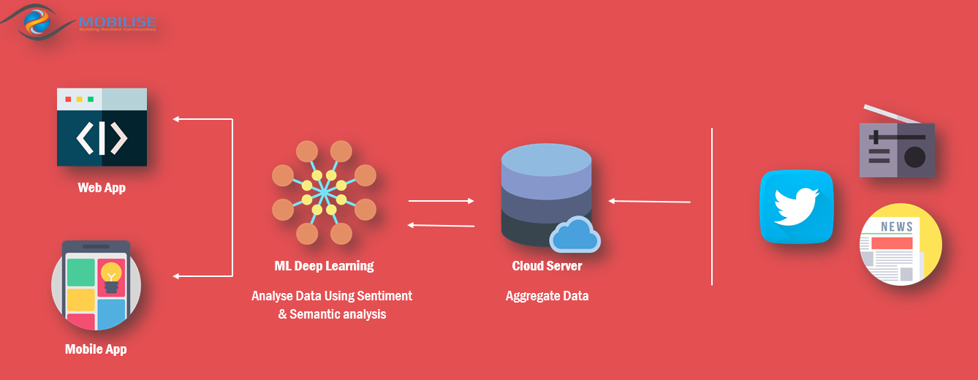

# Purpose of mobiles twitionary platform

* Reduce manual work
* Improve organization media campaign for public awareness
* Real-time data availability
* help in decision making

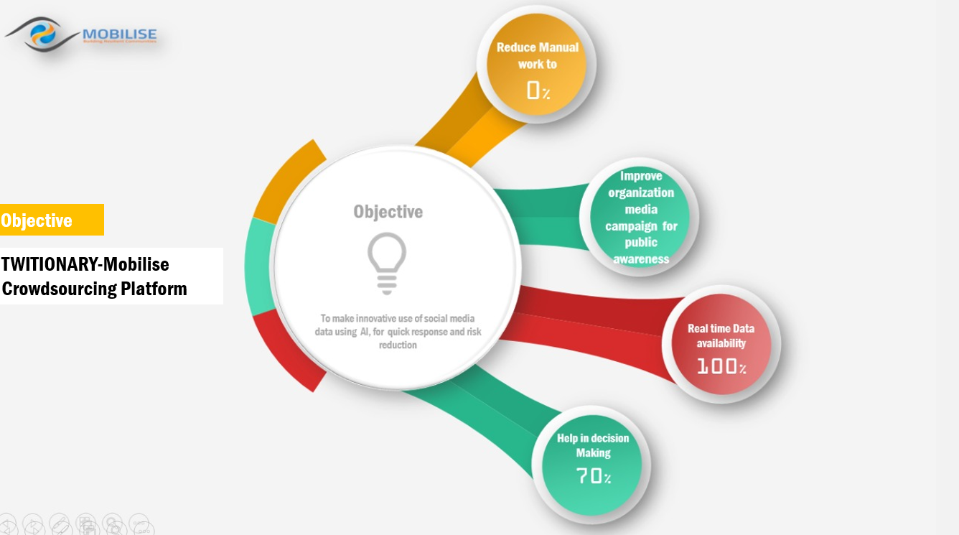

# Status of application

The web application is fully functionally hosted on Google cloud platform <http://34.68.136.134/blog/>

# What are the next steps?

* Add Statically/Graphically analysis based on scape data
* Currently, the platform is hosted on free space provided by Google cloud platform(GCP), the server has limitations this need to be hosted on a proper server
* For now, we can access <http://34.68.136.134/blog/> using IP address a proper domain need to be purchased
* After testing and finalization of the platform across mobile application need to be developed

# Tool used

* Python 3.8
* selenium webdriver
* tweepy
* vader sentiment
* Google Cloud Platform
* MySQL
* JavaScript
* Html/CSS Bootstape